**Servlet Project Setup**:

1.Click on file or (ctrl+n):

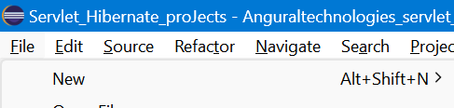

Click on other:

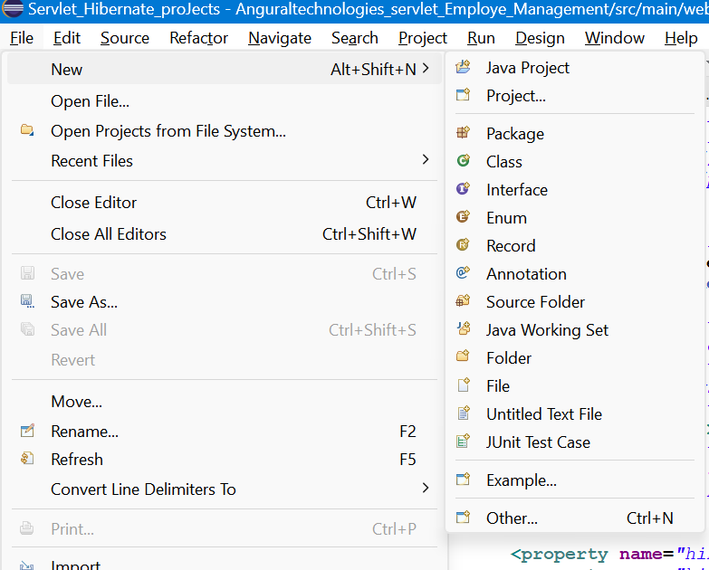

Search Maven Project:

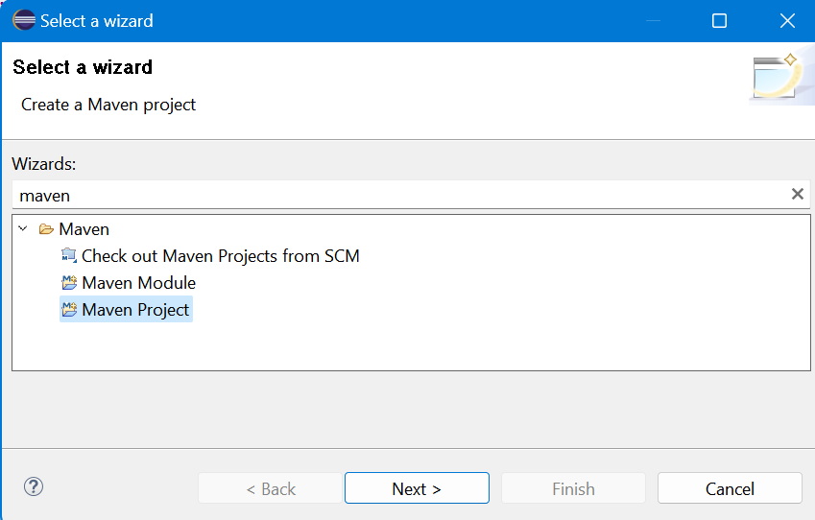

Click next:

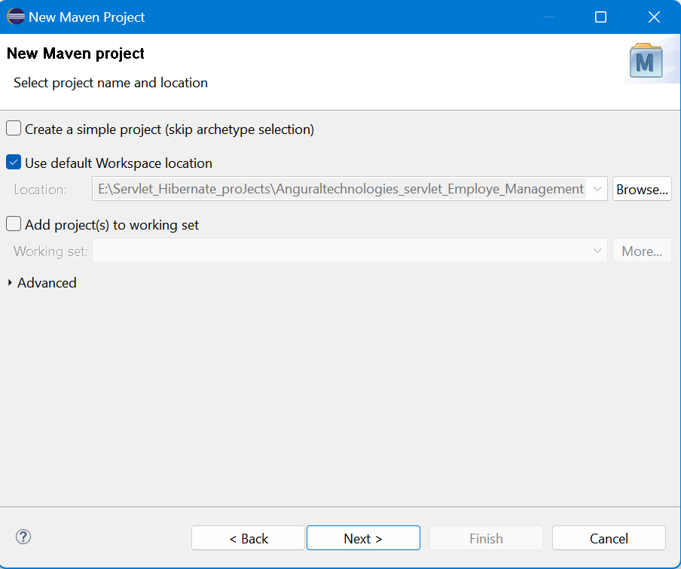

Wait and search maven-archetype-webapp in filter and select then click next:

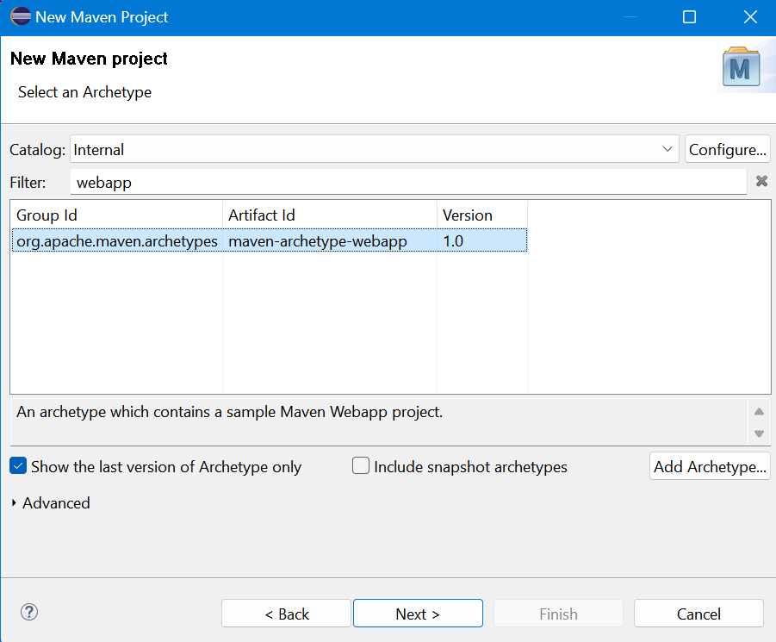

Provide package name or project name and click Finish:

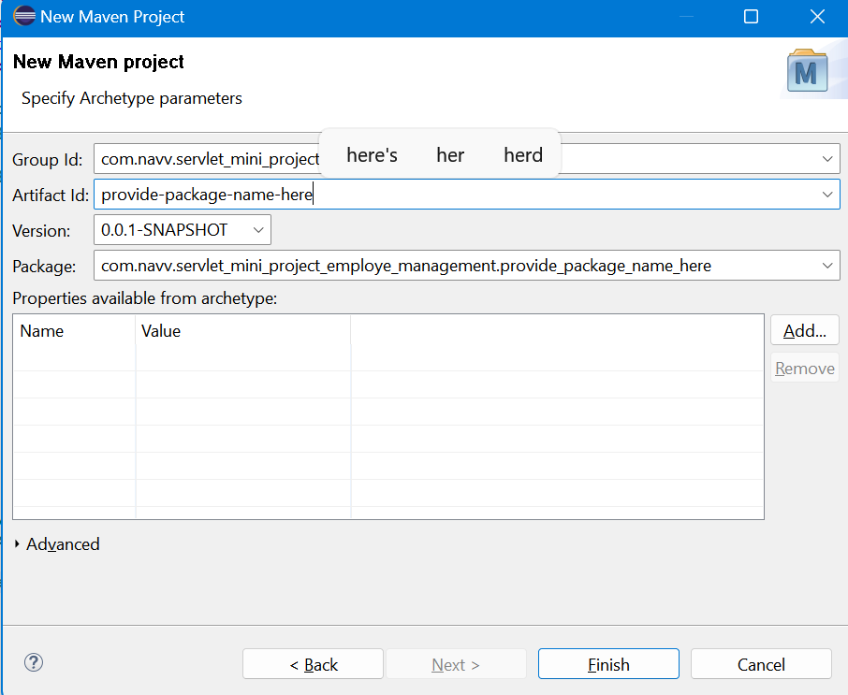

Project Created.

After that Right click on Project and click on Properties

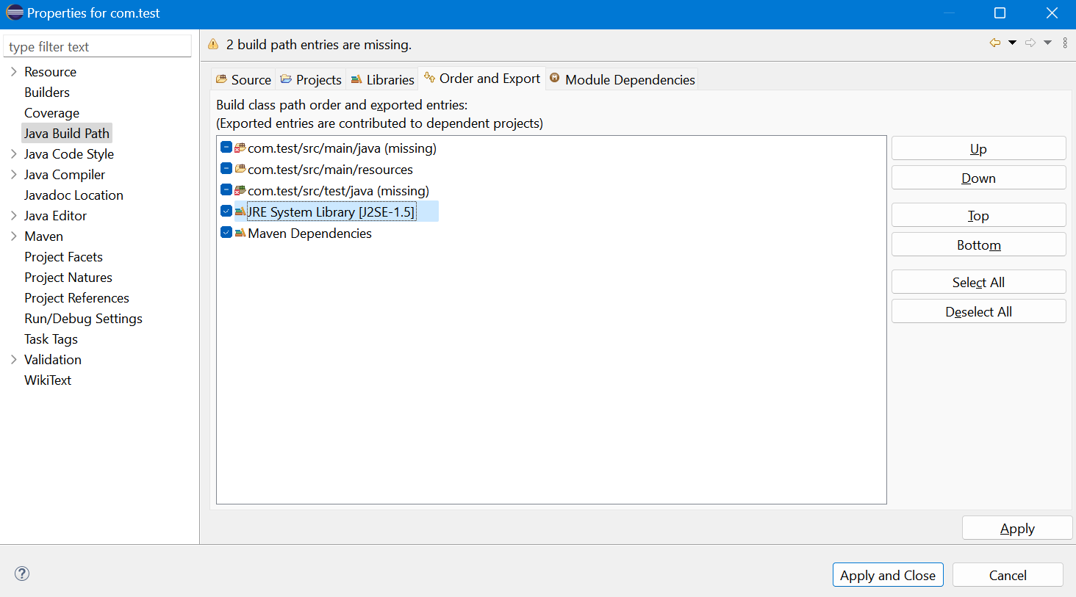

Here tick jre system and maven dependencies and click apply and click apply and close

After that again click on properties and click On Properties and click on project facet

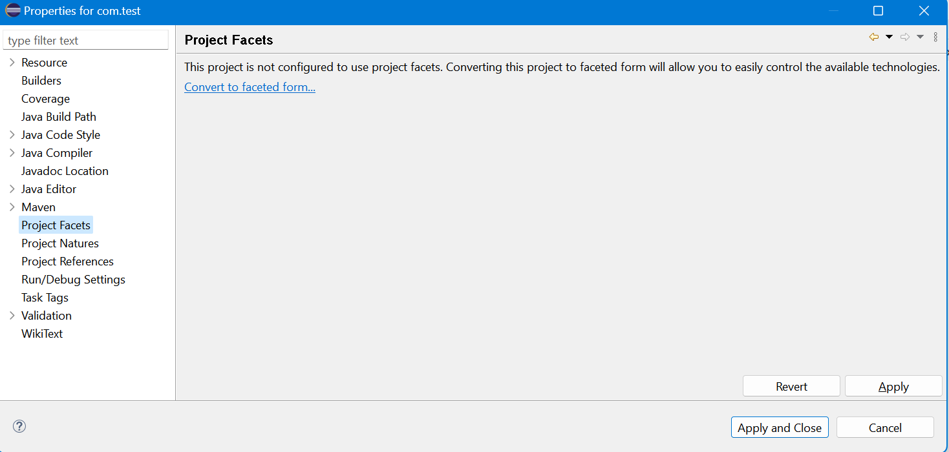

Click convert to facet from cthen tick Dynamic Web Module and Runtime tick Apache tom cat v9.0

And click apply and apply close:

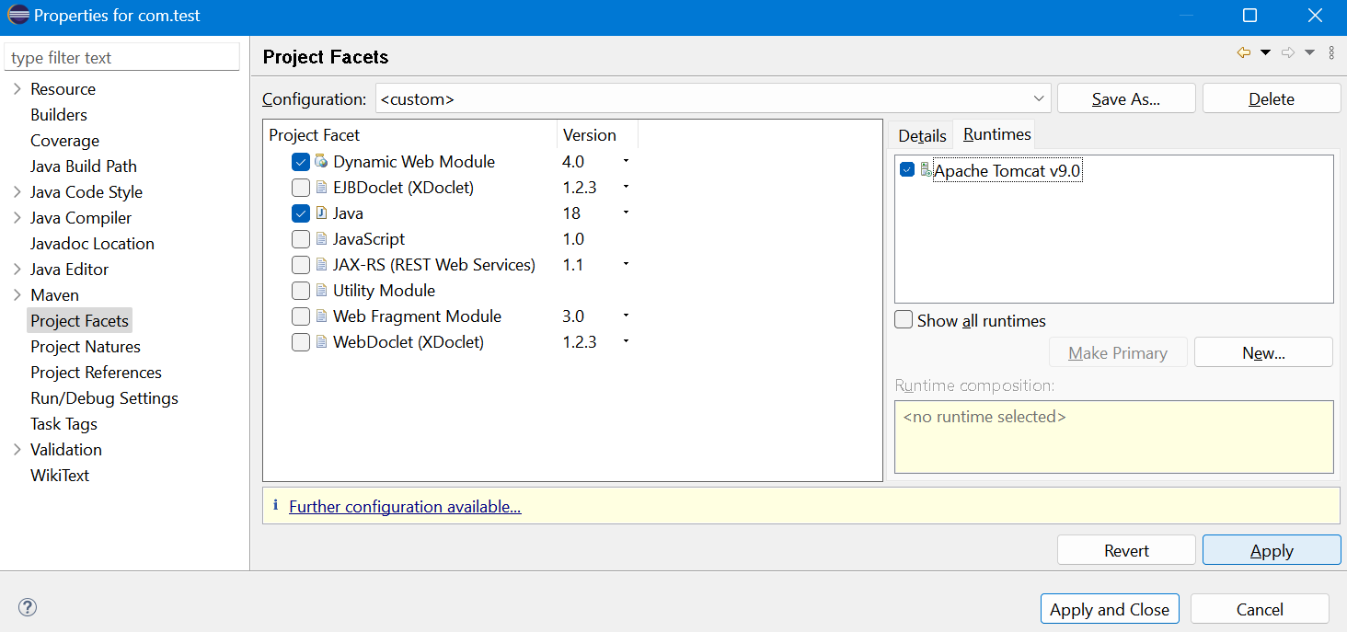

Again click on properties and click on Deployment Assembly and click on add button select java build Path and click next

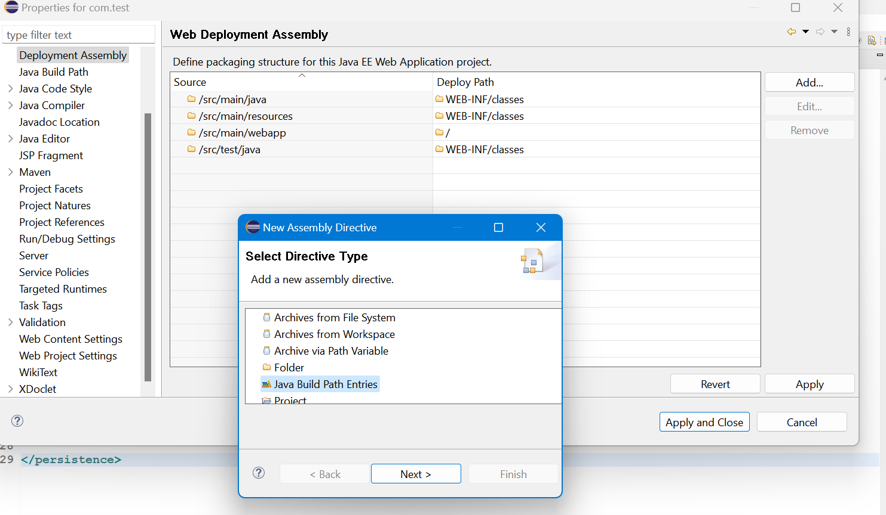

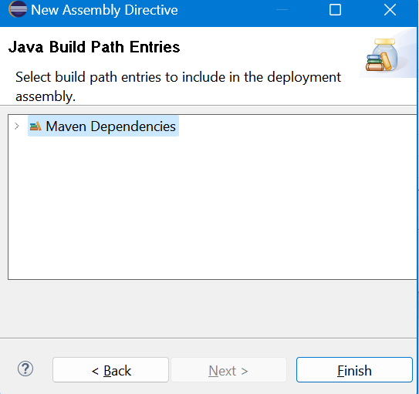

Then select ,aven Dependencies and click Finish then apply and apply and close

Add Dependencies in pom.xml File and After that Update Project and add Persistence.xml file in following location

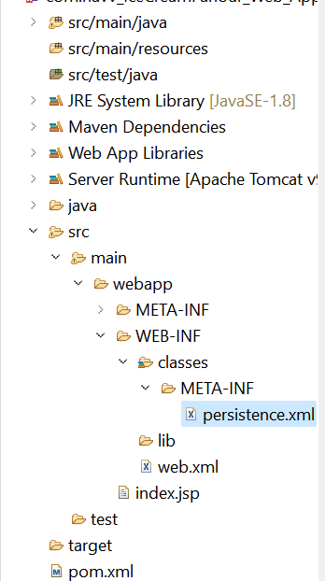 and Update Project maven Update Project

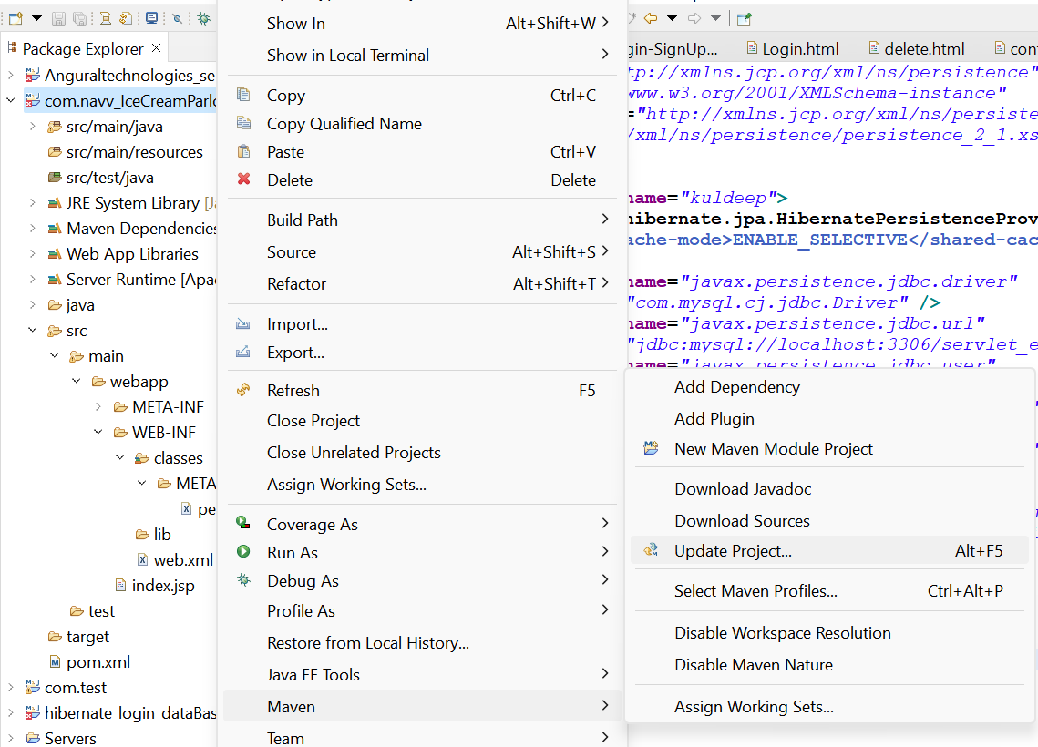

Tick Force update Of Snapshots/Release and Click Ok

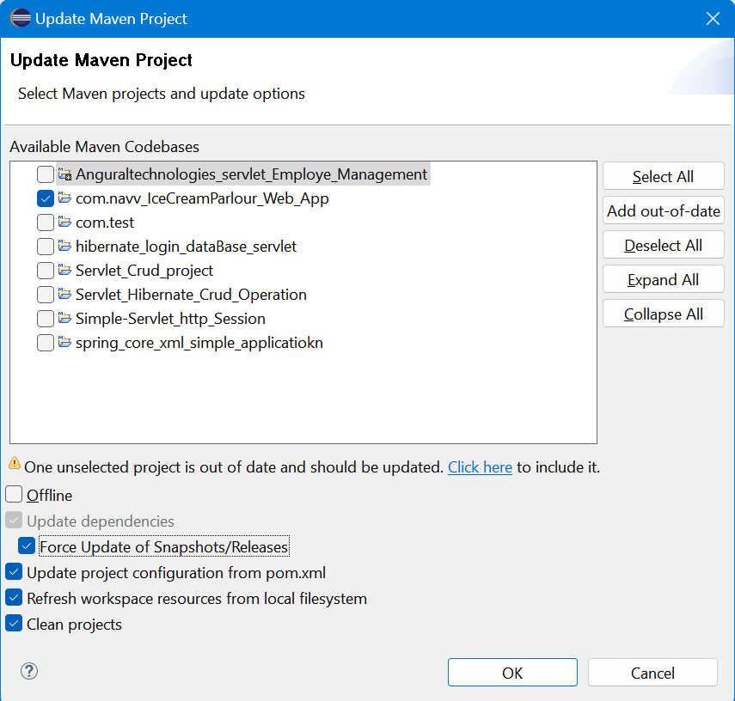

After Update project Done